Some Importers dances will be held at Bill & Carol Heiman’s Clubhouse (oval) at Lake Hinsdale Village in Willowbrook, IL. The address is 1 Clubhouse Drive.

The only entrance to the complex is on the south side (star), just west of the intersection of Route 83 and 67th St. There appears to be a gatehouse but it is unguarded.
- Enter the property, turn right at the stop sign adjacent to the guard house.
- Follow Lake Hinsdale Dr. around the perimeter (counter-clockwise).
- Turn left at Clubhouse Circle which is the second stop sign after the one at the guard house. (Note: There’s an iron gate and it looks like the road ends.)
- After the turn, the road looks like it splits; stay to the left and you are in the parking lot of the clubhouse.
The only “near the building” parking is for those autos with handicapped tags.
Contact Bill or Carol Heimann if you have other questions.

To get to Willowbrook from O’Hare Airport. These directions are from Google Maps (4/2021). This 20.3-mile trip takes about 25 minutes in no traffic.) Note: I-294 and I-88 are toll roads. Tolls can be paid online within 7 days of travel. There is no “manual” (cash) toll collection at this time.

- Follow signs from the airport to I-294 South [AKA Merge onto I-190 E (0.7 mi) and then take Exit 1D toward I-294 S/Indiana/S Tollway (0.4 mi).]
- Merge onto I-294 S (Toll road; 8.7 mi)
- Take exit 31A to merge onto I-88 W toward Aurora (Toll road; 2.9 mi)
- Take the I-88/IL-83 S exit (Toll road; 0.2 mi)
- Keep right at the fork to continue on Exit 137 and merge onto IL-83 S (5.8 mi)
- Turn Right (westbound) on 67th St, the first light after the light/large intersection at 63rd St. (Caution: The rightmost lane ends before 67th St so it’s best to be in the middle lane when you get to 63rd.) You should see the white water tower for Lake Hinsdale Village on the NW corner.

To get to Willowbrook from Midway Airport. These directions are from Google Maps (4/2021). This 17.3-mile trip takes about 17 minutes in no traffic.

- Head south on S Cicero Ave (0.3 mi)
- Make a U-turn at W 59th St (Pass by Starbucks on the right in 1.6 mi; 2.3 mi)
- Make a hard left to merge onto I-55 S (0.3 mi)
- Follow I-55 S to IL-83 N/Kingery Hwy in Willowbrook. This is Exit 274. (11.4 mi)
- Take exit 274 for IL-83 N/Kingery Rd (0.5 mi)
- Continue on IL-83 N/Kingery Hwy to 67th St. (1.4 mi)
- Turn Left (westbound) onto 67th St (0.2 mi). There is a stop light with a left-turn signal. You should see the white water tower for Lake Hinsdale Village on the NW corner.

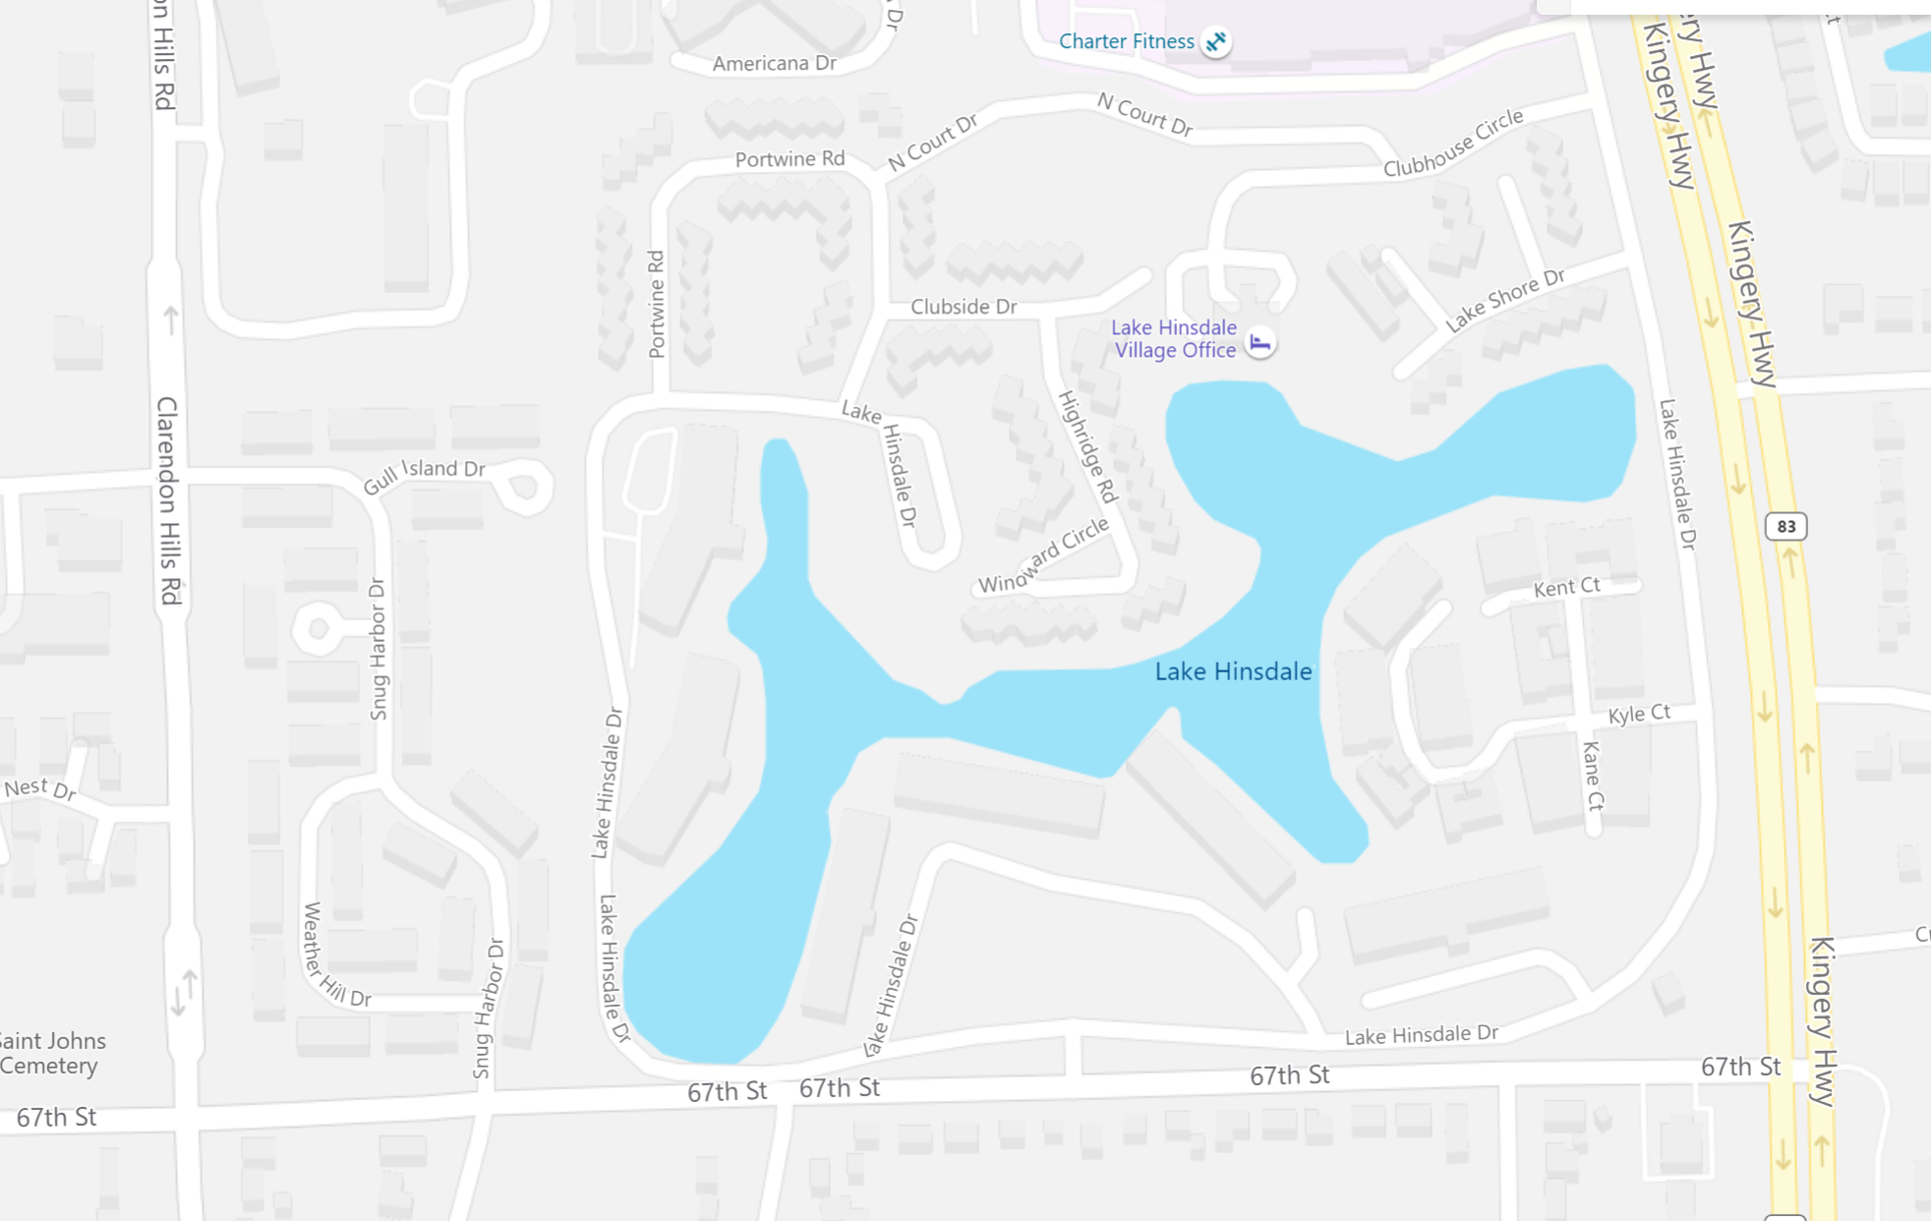

= Stop sign

= Entrance to Lake Hinsdale Village
= Club House (dance location) & Parking

